Safety Committee Minutes

Call to Order (May 2, 2019 1:04 pm)

Present: Arrowsmith, Jason; Engel, Elizabeth; Gomez, Dave; Hines, Daniel; Mack, Brian; Rukkila, Rheba; Sampson,Laura; Skreen, Janel; Terry, Lily; Wheeler, Nolan

Absent: Hamilton, Richard; Hammon, Kyle, Herbelin, Armando; Roeske, Gary; Rosi, David; Tim Timmreck (student rep);

Reading and Approval of Minutes from Previous Meeting

Corrections: Attendance and typos were edited as corrected
Minutes Accepted: Y
Moved:
Seconded: Approved: Unanymously

Accident Investigations
- On 4.18.19 a student poked his left thumb with a clean needle of an insulin syringe when his hand slipped on the needle cap. Recommendation: Twisting the cap can sometimes prevent hand from slipping off the body of the syringe.
- On 4.23.19 a student was burned when reaching for a disinfectant bottle that was on the far side of a microincinerator. Recommendations: Place the disinfectant away from the micro-incinerators.
- On 4.24.19 an instructor felt pain in his shoulder area when carrying a 4’x4’ sheetmetal from pick-up to storage rack with assistance. There were no mechanical lifting aids available. Recommendation: Heavy metal movers be considered for the welding department
- On 4.29.19 an employee fell off the lift gate of the Food Service truck when the lift gate broke. Recommendations: Increase safety inspections schedule on the lift mechanism; get a new truck.
- Follow-up to 3.15.19 incident where an employee’s hair was singed while attempting to light a gas BBQ grill: Nolan Wheeler reports that this is the second time someone has been burned or had a near miss with this grill. He will have the grill removed from service.
Accident Prevention Program Review Update
- Janel reports that there has been good progress, and expects that an initial draft will be ready for distribution to Safety Committee members by Fall 2019.
Safety Work Orders:
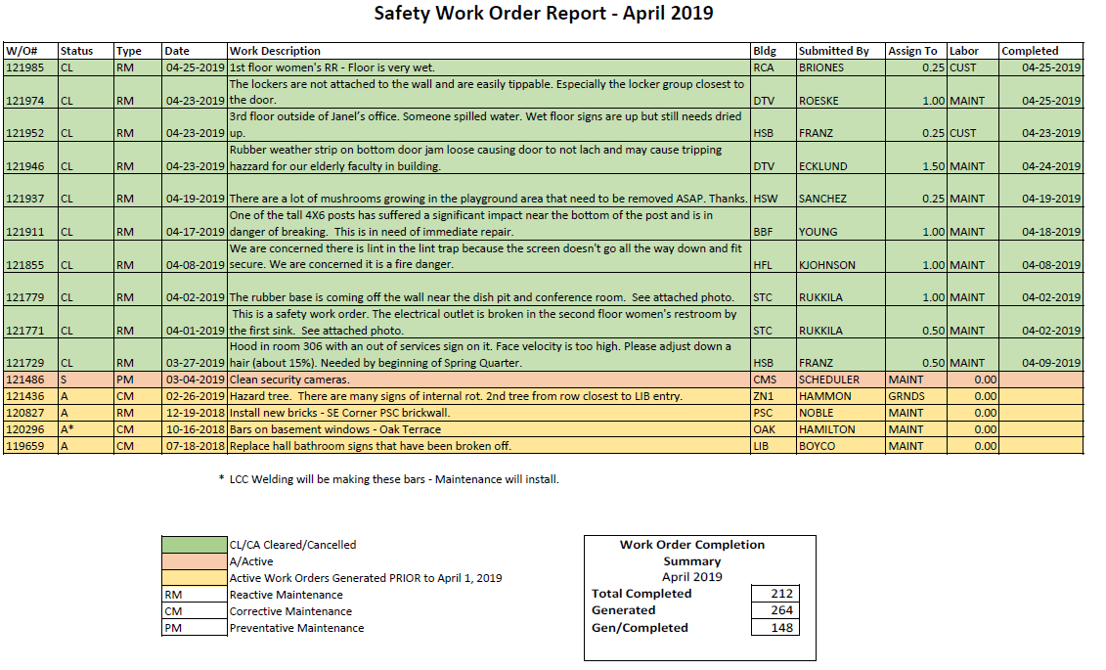
- Nolan believes the tree is not rotting, but that it needs to be pruned
Old Business
- The pitching machine discussed at the March 2019 meeting in the context of an incident investigation is not owned by LCC. There is no label on it showing ownership, vendor, or model name. Tracy Fuller does not have more information. Janel will follow up on ownership and operation details.
- The FBI speaker previously scheduled for April will be rescheduled.

New Business
- Janel reported that she sees the need to be away from her desk and meetings more, in order to do more safety audits on campus.
- CPR classes have been moved, but the new location is unknown. Rheba will follow-up on this.

Meeting Adjourned: 1:43pm
Next Meeting: Thursday, June 6 @ 1pm

Moved: Jason Arrowsmith
Second: Laura Sampson
Motion carried: Y

Minutes prepared by Elizabeth Engel

