Safety Committee Minutes

Call to Order (April 11, 2019 1:02 pm)

Present: Arrowsmith, Jason; Barker,Richard; Dennick, Shani; Engel, Elizabeth; Hammon, Kyle; Herbelin, Armando; Mack, Brian; Sampson,Laura; Skreen, Janel; Franz, Shelly

Absent: Franz, Shelly; Hamilton, Richard; LaPierre, Louis; Rosi, David; Roeske, Gary; Rukkila, Rheba; Terry, Lily; Tim Timmreck (student rep); Velasquez, Michael; Wheeler, Nolan; Gomez, Dave

Reading and Approval of Minutes from Previous Meeting

Corrections: As corrected
Minutes Accepted: Y
Moved: Janel Skreen
Seconded: Armando Herbelin

Accident Investigations
- On 2/26/19 a student slipped on ice in parking lot J and suffered a radial fracture and a bruised knee. Recommendations are for further de-icing of parking lots and walkways
- On 3/8/19 an employee injured her toe while chasing a child in the early learning center. Recommendations are possible policy changes for chasing running children
- On 3/13/19 an employee slipped on a wet floor and injured her hip,knee, and wrist. Recommendations are for supervisors to meet with housekeeping staff to remind them of their responsibilities of placing wet floor signs
- On 3/15/19 an employee singed their arm hair and eyebrows while attempting to light a gas bbq grill. Recommendations are for further employee training on proper procedure in operating and lighting bbq grills, or replacing the grill
- On 3/29/19 an employee scraped their shin, hand, and shoulder while stacking chairs. Recommendation is to not stack equipment that can be awkward to handle above shoulder height. Requesting help if put in that situation

Safety Work Orders: 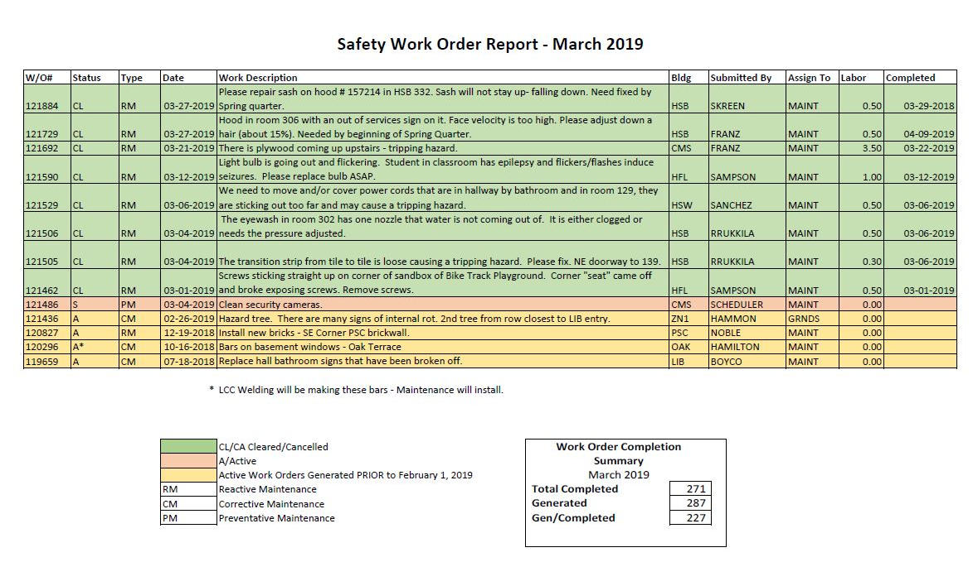
- Hazard tree work order will remain until further investigation into condition of the tree is completed
- Security cameras have been cleaned but work order has not been removed as of yet
- Welding is making bars to be placed on the basement windows at Oak Terrace
- Work order to replace bathroom hall signs will be removed as it is not a Safety Work Order
Old Business
- Elizabeth Engel will write a commendation to Betsy Richards, she will get with Brian Mack for the detail
- Pitching machine conversation tabled again till next month
- FBI speaker scheduled for April 24th @5pm. Topics will be Risk Assessment, Community Resources, Identifying Problem Individuals, and Active Shooter information. This is open to the public
- Remarks on Sean Kaufman lab safety training. From those that attended, they thought it was a great training full of great information
- There was an Informacast test on April 2nd that went well, there some technical issues that were identified that were not previously known

New Business
- The Early Learning Center is planning another large scale reunification drill. The date is set for August 28th.

Meeting Adjourned: 1:44pm
Next Meeting: Thursday, May 2nd @ 1pm

Moved: Brian Mack
Second: Janel Skreen
Motion carried: Y

