Safety Committee Minutes

Call to Order (March 7, 2019 1:00 pm)

Present: Arrowsmith, Jason; Gomez, Dave; Hammon, Kyle; LaPierre, Louis; Mack, Brian; Roeske, Gary; Rukkila, Rheba; Terry, Lily; Tim Timmreck (student rep)

Absent: Barker, Richard; Dennick, Shani; Engel, Elizabeth; Franz, Shelly; Hamilton, Richard; Rosi, David; Sampson, Laura; Skreen, Janel; Velasquez, Michael; Wheeler, Nolan

Reading and Approval of Minutes from Previous Meeting

Corrections: Kyle Hammon was not listed for the February meeting. He should have been on the absent list.
Minutes Accepted: Y
Moved: Louis LaPierre
Seconded: Jason Arrowsmith

Accident Investigations
- 5 total accident investigations reviewed. There were no recommendations made or actions taken by the Safety Committee on any specific accident. However, the committee recommended that an email be sent to Betsy Richards commending her on her First Aid response. Could Elizabeth author this email? A recommendation to table a procedure being developed for the pitching machine was made until the Coach is communicated with. Brian is following up on this.

Safety Work Orders: 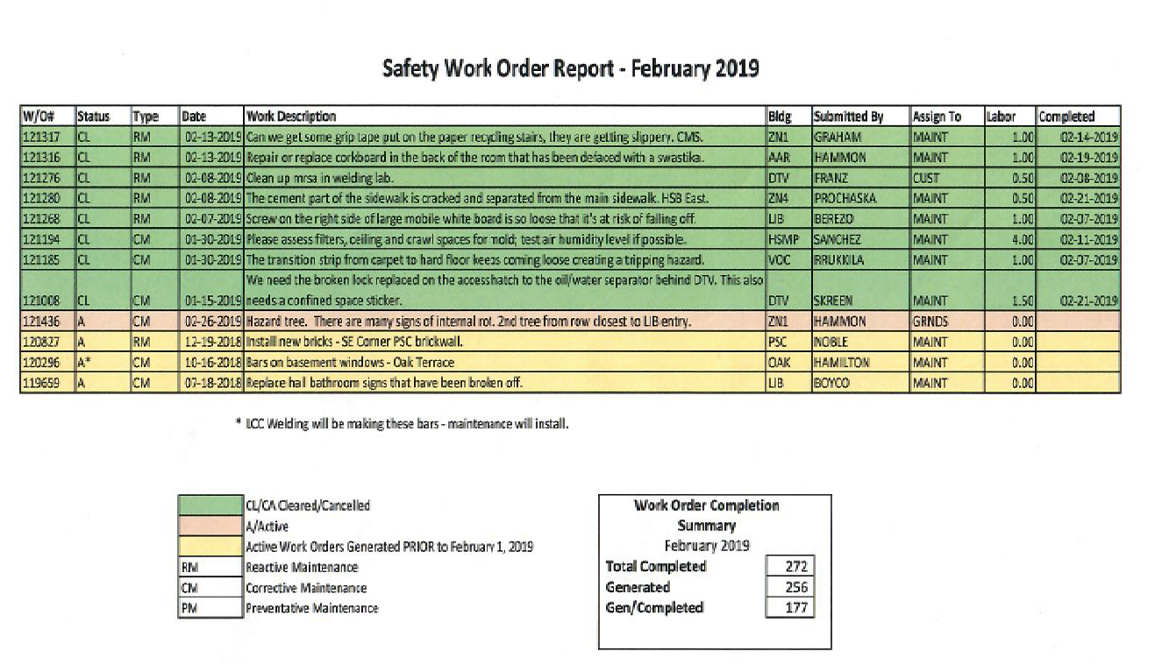

WO#119659- Kyle Hammon states the bathroom signs were replaced by his department but the holders from the broken signs are still in place.
Old Business
- LCC Accident Prevention Task Force… Brian stated the task force met about a week and a half ago. They should have something to show the committee at our next meeting.
- Lab Safety Speaker Shaun Kaufman will be here April 5 6-9pm… Kyle stated they Science Faculty are excited to attend.
- FBI Prevent violence in the schools – Jason Arrowsmith reported for Janel that the facilitator had to cancel but will be rescheduled.
- Stop the bleed training held Feb 13 all day. Dr. Mitchell who facilitated the training encouraged the placement of stations being placed on campus with training on these stations. Lorraine Churchill is looking at Grant Funding for Cowlitz County to purchase stations. Brian states they can fit these kits in the AED stations instead of adding new locations. Local schools, businesses, Fire departments, local bus agencies and railroad agencies attended the training.
- Fire alarm signage was removed from Main per discussion from Janel and Richard
- Discussion regarding “AED” signage within the buildings, not just outside. Tim Timmreck stated he and Janel had discussed ideas for signage. Janel is ordering signs for outside that show AED’s that are on the second floors.
.

- New Business
    - Emergency Preparedness (space holder)- Jason stated there will testing of the Emergency system during spring break to verify everything is working. Will update with a date and time.
Brian Mack stated a reunification drill is being planned in August for the Early Learning Center. More info to come.

Next Meeting Thursday April 11 @ 1:00 pm HSB 235

Meeting Adjourned: 1346

Moved: Jason Arrowsmith
Second: Kyle Hammon
Motion carried.

