Safety Committee Minutes

Call to Order (February 7, 2019 1:00 pm)

Present: Arrowsmith, Jason; Dennick, Shani; Engel, Elizabeth; Gomez, Dave; LaPierre, Louis, Roeske, Gary; Rukkila, Rheba; Sampson, Laura; Skreen, Janel; Timmreck (student rep); Velasquez, Michael; Wheeler, Nolan

Absent: Barker, Richard; Coder, Jacob; Franz, Shelly; Hamilton, Richard; Hammon, Kyle; Mack, Brian; Rosi, David; Terry, Lily;

Reading and Approval of Minutes from Previous Meeting

Corrections: None
Minutes Accepted: Y
Moved: Louis LaPierre
Seconded: Shani Dennick

Accident Investigations
- 5 total accident investigations reviewed. There were no recommendations made or actions taken by the Safety Committee on any specific accident. However, the committee recommended that an email be sent campus wide reminding people to slow down and be diligent in terms of safety. Janel agreed to author this email.

Safety Work Orders:
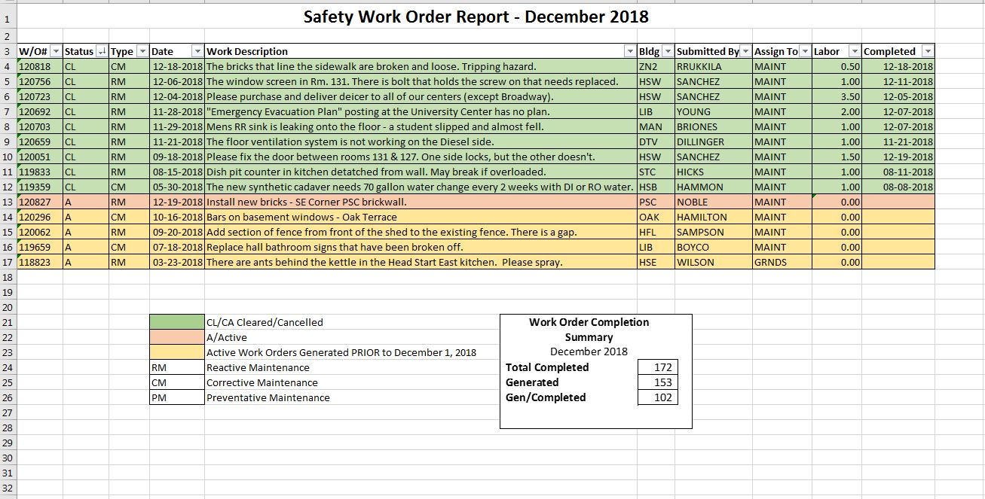

Safety Work Order # 121194 should be listed as completed.

Old Business
- Lab Safety Speaker Shaun Kaufman will be here April 5 6-9pm
- FBI Prevent violence in the schools - open to public May 1
- Stop the bleed training on campus Feb 13 all day
New Business
- Committee discussed the fire alarm not active signs posted on the outside of Main. Janel was to email Richard Hamilton to see if the signs could be removed.
- Questions regarding emergency lighting in Main. Janel to check on this.
- Discussion regarding “AED” signage within the buildings, not just outside. Janel to assess if/where additional signage needed.
- Discussion regarding ice melt on campus. Info regarding walking safely on ice to be included with previous email regarding slowing down.
- Tim Timmreck requested additional security cameras in VOC. VOC may be part of demolition so camera additions have been tabled.

Next Meeting Thursday March 7 @ 1:00 pm HSB 235

Meeting Adjourned: 1355

Moved: Rheba Rukkila
Second: Louis LaPierre
Motion carried.

