Safety Committee Minutes

Call to Order (January 10, 2019 1:00 pm)

Present: Arrowsmith, Jason; Barker, Richard; Dennick, Shani; Engel, Elizabeth; Franz, Shelly; Gomez, Dave; Hammon, Kyle; LaPierre, Louis; Mack, Brian; Roeske, Gary; Rukkila, Rheba; Sampson, Laura; Terry, Lily; Velasquez, Michael

Absent: Coder, Jacob; Hamilton, Richard; Rosi, David; Skreen, Janel; Wheeler, Nolan

Reading and Approval of Minutes from Previous Meeting

Corrections:
Minutes Accepted: Y
Moved: Kyle Hammon
Seconded: Gary Roeske

Accident Investigations
- The one accident report that there was for this month was not ready to present to the committee so it will be brought to next months meeting

Safety Work Orders:
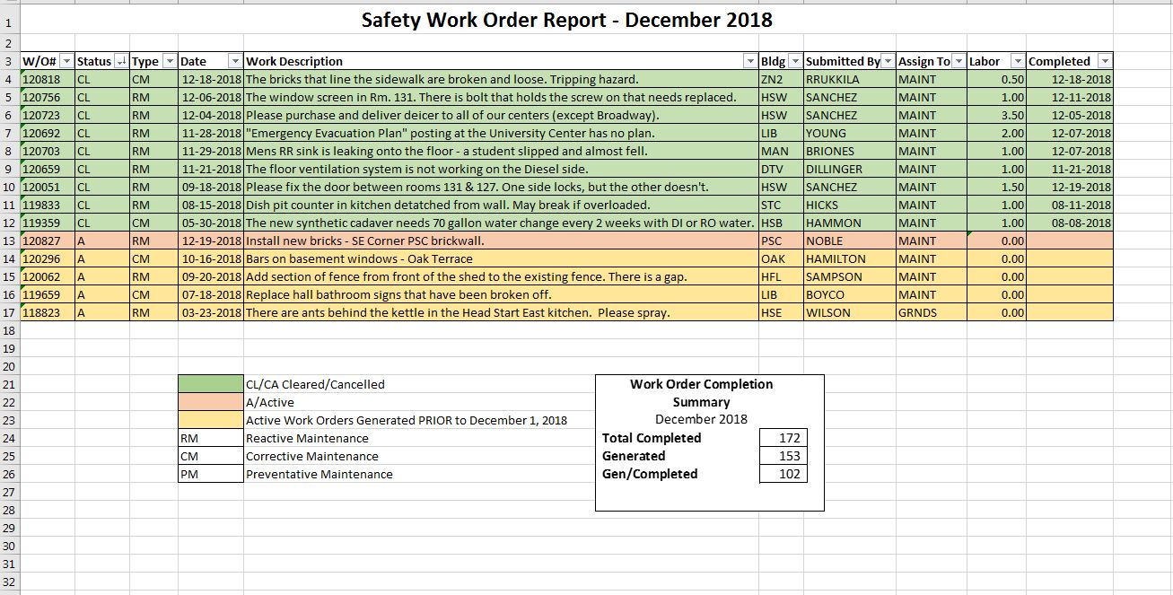

Old Business
- LCC Accident Prevention Program Task Force Report
  - There is a Doodle poll out to schedule another meeting, the group is hoping to meet before the next Safety Committee meeting
- Emergency Preparedness
  - None
- Lab Safety Meetings
  - A one day workshop is being planned at some point during the Winter Quarter, the date is still tentative
New Business
- Possibility of changing meeting time to 1:30pm to better accommodate committee members. Will be addressed again at later meetings
Next Meeting Thursday February 7th @ 1:00 pm HSB 235

