Safety Committee Minutes

Call to Order (December 06, 2018 1:03pm)

Present: Arrowsmith, Jason; Barker, Richard; Engel, Elizabeth;Hamilton, Richard; Hammon, Kyle; Mack, Brian; Roeske, Gary; Rukkila, Rheba; Sampson, Laura; Skreen, Janel; Velasquez, Michael

Absent: Coder, Jacob; Dennick, Shani;Gomez, Dave; Franz, Shelly; Rosi, David; Wheeler, Nolan

Reading and Approval of Minutes from Previous Meeting

Corrections:
Minutes Accepted: Y
Moved: Kyle Hammon
Seconded: Gary Roeske

Accident Investigations
- On 11/5/18 an employee was getting a box out of the print shop cart and cut their hand on the corner of the door on the cart. The recommendation from the investigator is to add a strip of felt to the area that caused the cut to prevent further injuries
- On 11/20/18 a student tripped and fell over the edge of a driveway ramp that was not very visible at night. A recommendation was to paint the edge yellow to make it more visible
- On 11/29/18 a student worker tripped and fell while chasing a child that had escaped from the daycare. The investigator recommended a baby gate but that would violate fire code so conversation and training will be recommended

Safety Work Orders:

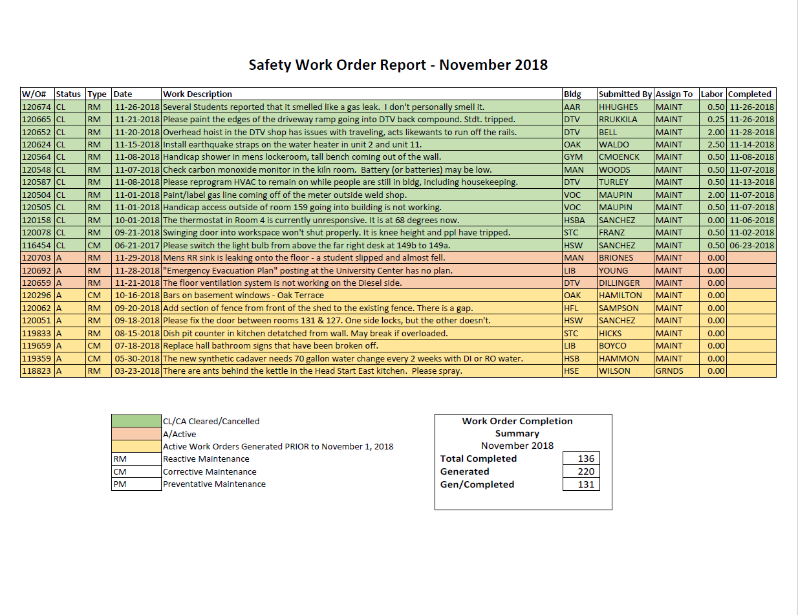

Old Business
- LCC Accident Prevention Program Task Force
  - Met on 11/30 and went over several sections of the document and created a plan and timeline to complete the document and bring it to the Safety Committee.
- Lab Safety
  - Janel Skreen shared some quick reference guides
New Business
- Laboratory Quick Reference Guide
  - Janel Skreen shared some of the quick reference guides that Judi Howland created for chemistry labs that are repeated by the department. These documents contain information such as PPE needed, chemical SOP’s, and spill clean-up information
- The Main building fire system will be completely offline beginning 12/10 so contractors can begin to replace and upgrade the fire panel and suppression system
Next Meeting Thursday January 10th @ 1:00 pm HSB 235

