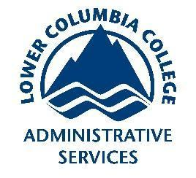
Safety Committee Minutes

Call to Order (November 1st, 2018 1:03pm)

Present: Barker, Richard; Engel, Elizabeth; Hammon, Kyle; Roeske, Gary; Rosi, David; Rukkila, Rheba; Sampson, Laura; Skreen, Janel; Velasquez, Michael; Wheeler, Nolan

Absent: Arrowsmith, Jason; Coder, Jacob; Dennick, Shani;Gomez, Dave; Hamilton, Richard; Hammon, Kyle; Franz, Shelly; Hamilton, Richard; Mack, Brian;

Reading and Approval of Minutes from Previous Meeting

Corrections: In Elections, Brian Mack was confirmed as Vice Chair, Bylaw revision, change to read: The committee will elect a Chairperson at the first fall quarter meeting...
Minutes Accepted: Y
Moved: Kyle Hammon
Seconded: Gary Roeske

Accident Investigations
- A student burned their finger on a hot plate in a science class. Further training on allowing hot objects to cool properly is recommendation from investigator
- A student began to feel sick from fumes thought to be from concrete sealant that was being applied outside the library. After the student was brought out to fresh air he began to feel better. The fumes were brought into the building through the HVAC system. Recommendation was to dampen ventilation system until exposure threat was removed.
Safety Work Orders:

Responses from Shelly Franz to questions from Safety Committee
- What is the process for including a job on the Safety Work Order list?
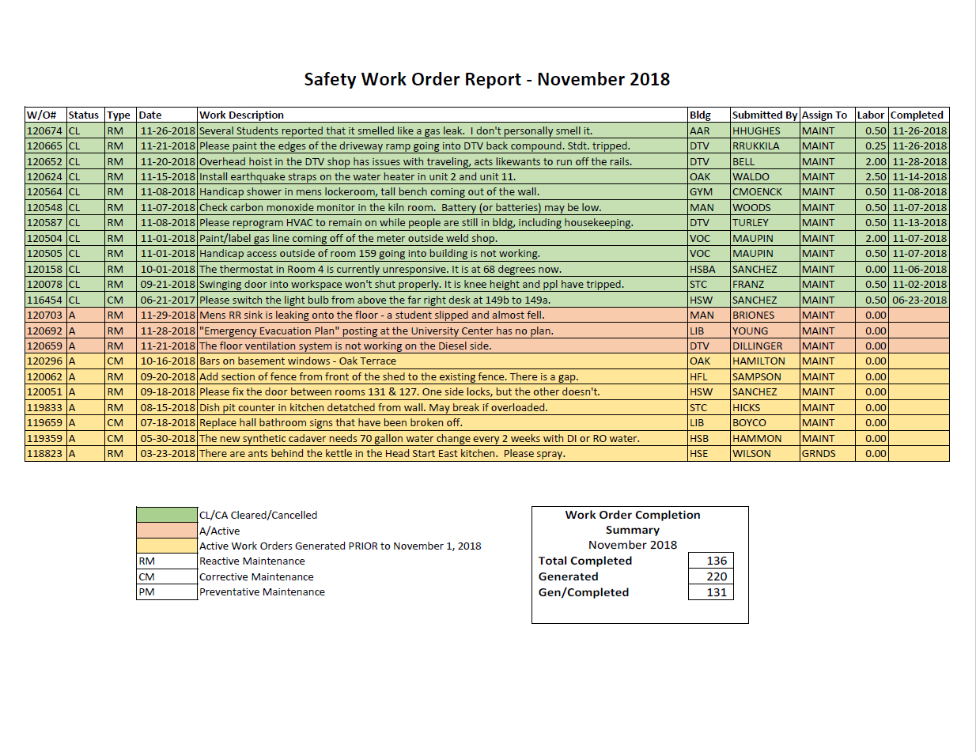
They just need to indicate in the request – either by phone, email, or through the online site, that it is a safety issue. There was a glitch with the system a while back where reports I pulled weren’t pulling the request type data and I had to go through each month’s work order one by one - so some may have been missed? Let me know if you think there’s a work order someone thinks should be on there and isn’t and I will investigate why it isn’t being pulled into the report.
- When the committee reviews the Safety Work Order Report, it is common for some to wonder how and when items will be moved from the yellow "Active Work Orders" section, when the work request is more than three months old. Is there a general rule for that? Or should we ask about a specific item after it comes up at a meeting?
So, if a work order is printed, given to the employee and completed, but NOT turned in – it will not clear in the system and show up as completed. Occasionally, one of these work orders that are in limbo will show back up and we can then enter the information and mark it as completed. However, the completion date will often be months prior, so when I pull the current month’s report – it won’t show up. So, if there was a work order that was generated in May and completed in June, but I don’t receive the paperwork order until September, I will complete it in the system with the original completion date. When I pull September’s report – that work order will completely disappear. To make sure that work orders don’t completely disappear, I will manually input it into the report. If there is a specific work order that is old that you would like investigated though, let me know and I will do some digging. Sorry that answer is way longer than it needed to be!

Old Business
- Earthquake Drill Report
  - Earthquake drill was a success. One clock did not activate. Prompted a lot of great discussion.
- Patriot Prayer Rally tomorrow at 10am.
  - Extra security patrols will be on hand
- LCC Accident Prevention Program Task Force Report
  - Goal 1: Create new template w/ sections outline included introductory language
  - Goal 2:
- Bylaws revision was approved
- Lab Safety
  - Adam Wolfer is the new Natural Sciences department chair
- Cowlitz 2 Hazardous Materials Unit came on campus to do an exercise in the Earth Science lab to search for radioactive material. While here they located multiple items that were of some concern. Janel Skreen contacted the Department of Health, they came and removed a uranium rock and a 1930’s era radioscope
New Business
- No new business

Next Meeting Thursday December 6th @ 1:00 pm HSB 235

