Safety Committee Minutes

Call to Order (October 4th, 2018 1:03pm)

Present: Arrowsmith, Jason; Barker, Richard; Coder, Jacob; Engel, Elizabeth; Gomez, Dave; Hamilton, Richard; Hammon, Kyle; Roeske, Gary; Rosi, David; Rukkila, Rheba; Sampson, Laura; Skreen, Janel; Velasquez, Michael; Wheeler, Nolan

Absent: Dennick, Shani; Franz, Shelly; Hamilton, Richard; Mack, Brian;

Reading and Approval of Minutes from Previous Meeting
Corrections: None
Minutes Accepted: Y
Moved: Janel Skreen
Seconded: Rheba Rukkila

Accident Investigations
- An employee injured their shoulder while closing a gate behind the weld shop. Preventative maintenance was suggested to make the gate easier to open
- An employee at Memorial Park Head Start was pulling a box off of a shelf when the shelf and a box came loose and fell on the employee, injuring the employee's pinky finger. Campus Services has a safety work order to secure the shelf

Elections:
- Chair: Jason Arrowsmith nominated Elizabeth Engel with a second by Rheba Rukkila. The nomination was accepted, a vote was carried and passed by the committee
- Vice Chair:

Safety Work Orders:
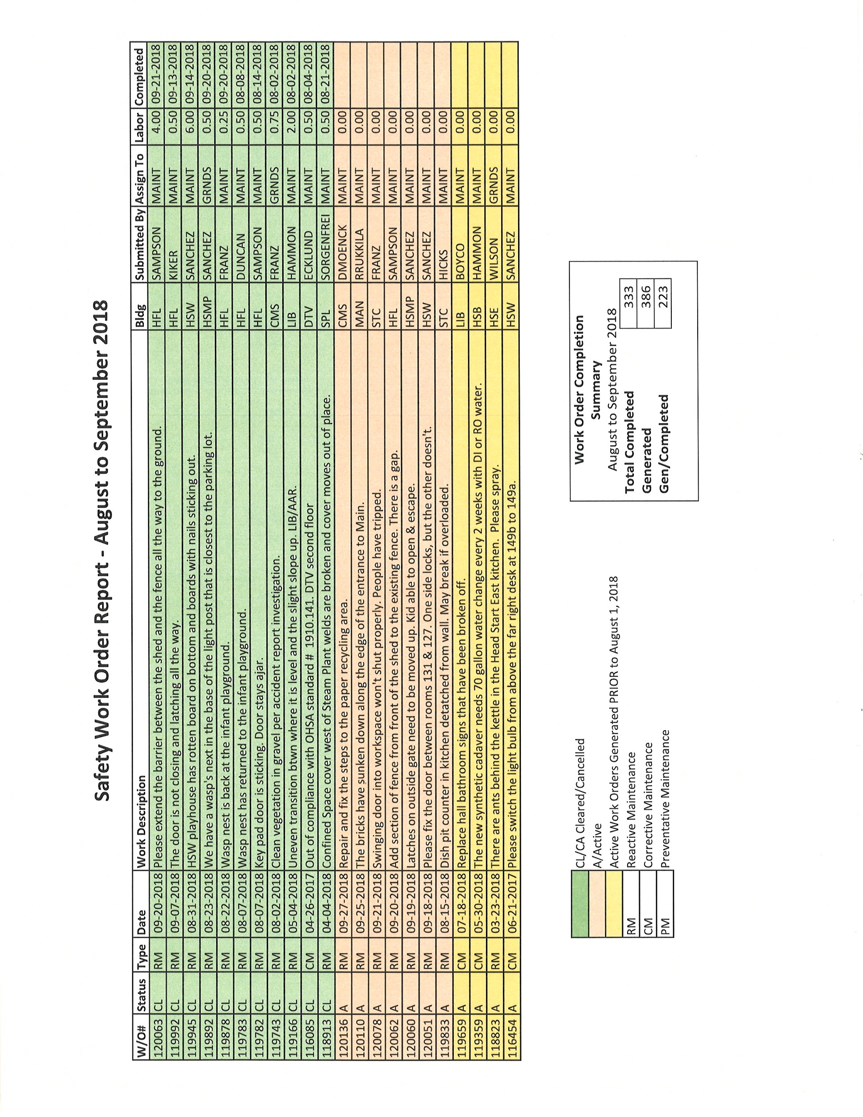

Old Business
- Emergency Preparedness: Safety Week 10/1-10/4: Monday Run Hide Fight, Tuesday Coffee with a Cop, Wednesday Sexual Assault/Domestic Violence Awareness, Thursday Emergency Preparedness
- Great Washington Shakeout will be held on 10/18 @ 10:18 am. The Informacast system will be used.
- The committee is forming a group to revise and update LCC's Accident Prevention Program
- Lab Safety Meeting: (Space Holder)
- Glove Use: (Space Holder)

New Business
(tabled from September meeting)
- Should we revise bylaws to read that a new chair and vice-chair shall be elected each October (instead of September)? Here are the relevant sections from the bylaws:
- The Committee will elect a Chairperson each September, with a one-year term, and an unlimited number of possible terms. The Chairperson shall set the agenda, lead the meetings, and provide leadership through encouraging equitable participation of all committee members.
- The Committee will elect a Vice-Chairperson, with a one year term, and an unlimited number of possible elected terms. The Vice-Chairperson shall substitute for the Chairperson as needed.
- A motion was made and passed by the committee to accept this change. Nolan Wheeler will take this recommendation to Cabinet

B. Meetings will continue on the first Thursday of each month at 1:00 pm

Next Meeting Thursday November 1st @ 1:00 pm HSB 235

