Safety Committee Minutes

Call to Order (August 2, 2018 at 1:05 PM)

Present: Arrowsmith, Jason; Barker, Richard; Dennick, Shani; Engel, Elizabeth; Franz, Shelly (sub for Richard Hamilton); Gomez, Dave; Rukkila, Rheba; Sampson, Laura; Skreen, Janel; Wheeler, Nolan

Absent: Coder, Jacob; Hamilton, Richard (sent sub); Hammon, Kyle; Herbelin, Armando; Mack, Brian; Roeske, Gary; Rosi, David; Wolgamott, Carleen

Reading and Approval of Minutes from Previous Meeting
Corrections: Add Rheba Rukkila to “Present” section of for June 2018 minutes

Minutes Accepted: Y
Moved: Nolan Wheeler
Seconded: Janel Skreen

Accident Reports

An employee nicked their finger with a knife while cutting lemons to be used in centerpieces for a campus function. Gloves were not used. Using gloves in the future would make for safer practice.
- An employee at Broadway Learning Center stepped from the sidewalk to an uneven playground surface and twisted her foot. A representative from the Safety Committee will reach out to the Longview School District and about recommendation from the investigator to grade this area of the playground
- An employee strained their knee while stepping from a sidewalk to an uneven surface near the state vehicle parking area behind CMS. A work order has been made to level out the area
- An employee at the Teen Center located at R.A Long High School got their foot caught on a baby gate while stepping over it and tripped, landing on their knee on the ground. Further safety training and the recommendation to install a hinged baby gate was given by the investigator

Safety Work Orders:
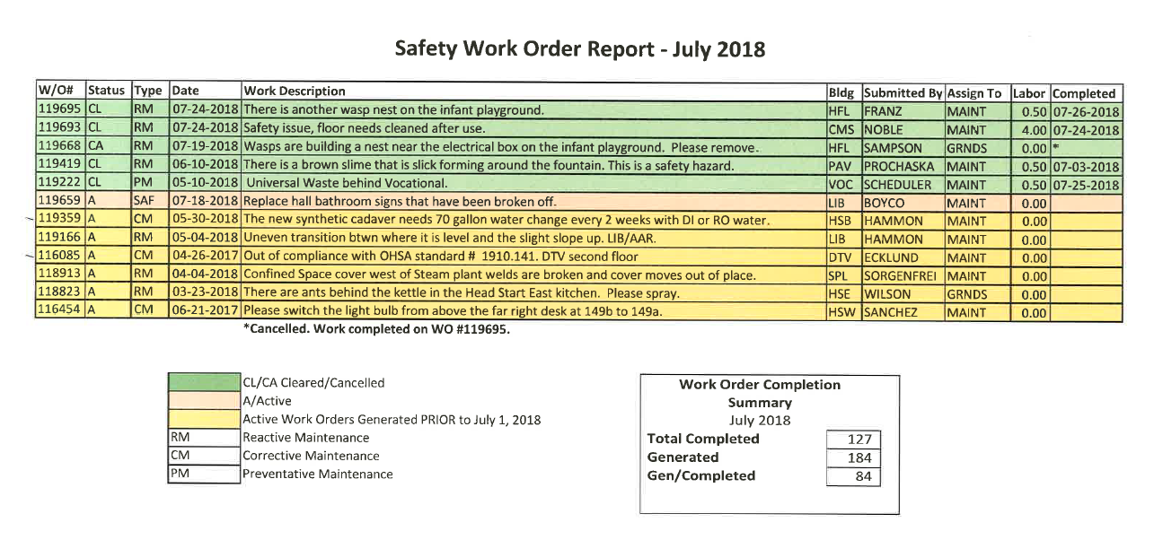

Shelly will follow up on work order #118913 involving a damaged confined space cover behind steam plant
- Work order #119359 is not a safety work order and will be removed from this list
- Work order #116085 will be removed from list because it was resolved

Old Business
- Emergency Preparedness: Reunification drill is scheduled for August 29th
- Lab Safety Meeting: (Space Holder)
- Glove Use: (Space Holder)

New Business
- Janel is drafting a new procedure for vendors and contractor to check in with security and obtain a vendor badge to wear while on campus
- Janel discussed the need to encourage employees to wear their official ID badges at all times while on campus
- Elizabeth and Janel are going to create a template letters for requesting additional information from accident investigators and for making safety recommendations.

Next Meeting
Thursday, September 6th @ 1:00pm (HSB 235)

Adjournment
Motion: Rheba Rukkila
Second: Jason Arrowsmith
Approved: All (time: 2:00pm)

